|  |
| --- |
| Functional Specification Document  <SpaceX/NASA > |

**DOCUMENT VERSION <V1>**

**<19.05.2019>**

**AUTHORS**

**This is where you add all the authors to the document**

|  |  |  |
| --- | --- | --- |
| **Name** | **Role** | **Department** |
| Alida F. G. Nordhus | Project manager | Digital Development |

**DOCUMENT HISTORY**

**If any changes are added to the document, after it has been published, you version control the document and add the version names here.**

**You also add the changes which were made to the document here.**

|  |  |  |  |
| --- | --- | --- | --- |
| **Date** | **Version** | **Document Revision Description** | **Document Author** |
| 01-01-1990 | V1 | Draft Version | Justine Domingo |
|  |  |  |  |
|  |  |  |  |
|  |  |  |  |
|  |  |  |  |

**APPROVALS**

**All members who will be signing off and approving the document.**

|  |  |  |  |
| --- | --- | --- | --- |
| **Approval Date** | **Approved Version** | **Approver Role** | **Approver** |
| 01-01-1990 | V1 | Development Team Leader |  |
|  |  |  |  |
|  |  |  |  |

**Table of Contents**

1. Introduction (give a brief description of the company) 6

1.2 Purpose of the document 6

1.3 Project Scope 7

1.4 Scope of the document 7

2.2 System Actors 9

2.3 Dependencies and Change Impacts 10

3. Functional Specifications 10

3.1 Develop an online site and mobile app 10

6. Reporting Requirements 12

7. Integration Requirements 12

8. References 15

# **Introduction** (give a brief description of the company)

# SpaceX/NASA is a company that launches rockets and spaceships. It started in 2002 to develop space technology. The goal is to make it possible for people to live on other planets. They have over 6000 employees, 3 vehicles and over a hundred launches contracted.

# **Purpose of the document**

## Give a description of why this document is being written.

# The purpose of this document is to document the business requirements and functional rules of the SpaceX microsite. This document will include a basic mockup of the microsite.

# All system requirements and restraints will be documented.

# **Risks and Assumptions**

## List all Risks and Assumptions

## e.g.

|  |  |  |  |
| --- | --- | --- | --- |
| **Risk** | **Level** | **Impact** | **Responsible** |
| User logins will not be migrated to the new portal | High | Users will not be able to login in using their existing login details | Development Team |

# **System/ Solution Overview**

## Provide any appropriate graphical representations that are relevant to the system and project such as a context/interface/data flow diagram, application screen flow, site map, or process flow. Add as many as needed.

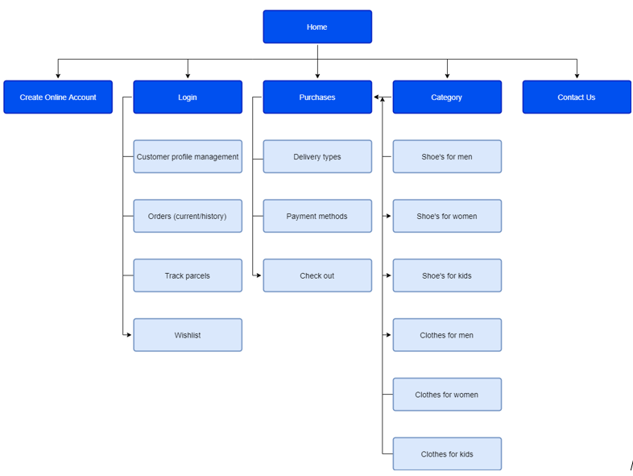

# **Functional Specifications**

## 

## <Start describing the specifications related to the overall system here. You may want to create a table/ index of all functionalities explained in the sections below and link them to the items below>

## <Group your functional specifications as appropriate for your project. You may want to divide them by screens, functional areas, user role, JIRA tickets or high-level functions Vs detailed functions or any other way that works for your project>

## e.g.

### Develop a microsite for SpaceX.

### Purpose/ Description

## Develop an online microsite for SpaceX to promote their work on space technology.

### Use case

## Map the functional requirement to one or more use cases mentioned in the Business Requirements document. If the use case is not described in detail in the Business Requirements document, describe the use case here. This typically includes the element s in the following table.

|  |  |
| --- | --- |
| **UC-1** | **Create an online payment page** |
| **Primary Actor(s)** | Customers |
| **Stakeholders and Interest** | CEOBusiness Owner |
| **Trigger** | Create a microsite for SpaceX/NASA |
| **Pre-conditions** | Microsite does not exist |
| **Post-conditions** | Microsite page successful |
| **Main Success Scenario** | I go to the microsite and choose a product for the shopping bagI arrive at my shopping bag and press “go to payment”I then arrive at payment info and fill in some of my personal details for checkout  * 1. The page takes me to delivery and payment option   2. I choose a method to pay and purchase the product   3. I get a confirmation message after purchase and an option to register for quicker checkout next time   4. I register as a customer with my chosen username and password   5. I get a confirmation in my mail that my purchase is complete |
| **Extensions** | If URL does not work, try google search for SpaceX/NASA microsite |
| **Priority** | High |
| **Special Requirements** | An option to register for quicker checkout at later time??? |
| **Open Questions** | <Notes and questions> |

Build a microsite for SpaceX or NASA. This should focus on space technology.

A *microsite*is a branded, self-contained site, usually on a its own domain, with a single purpose and a limited number of pages. The purpose can be promotional or editorial, and be may linked to a specific event or period of time. A microsite is usually built as an addition to an existing brand website.

# **Mock-up**

## Provide the mock-up of the functionality or a mock-up of the entire page. This can be a simple drawing of the layout of the site and mobile app.

**Mockup- online payment page: Mockup- payment page- app:**

# **Integration Requirements**

## <Identify the integration needs and state all required interfaces with anything external to this solution including hardware, software, and users. Include Architectural overview diagrams, high level data flow diagrams, table structures and schema, interface protocols, API’s, Error conditions, Error validations and messaging needs, Auto processing requirements etc. You can optionally state hardware and software dependencies, Upgrade requirements, compatibility issues with existing frameworks and solutions, etc>

## (Data Flow Diagrams, Interface Diagrams – if necessary)

